News listing page – Further Reading
https://www.investhk.gov.hk/en/news.html
display the further item in the listing for NEWS section. If there are no item, the Further Reading“ section will be hidden.
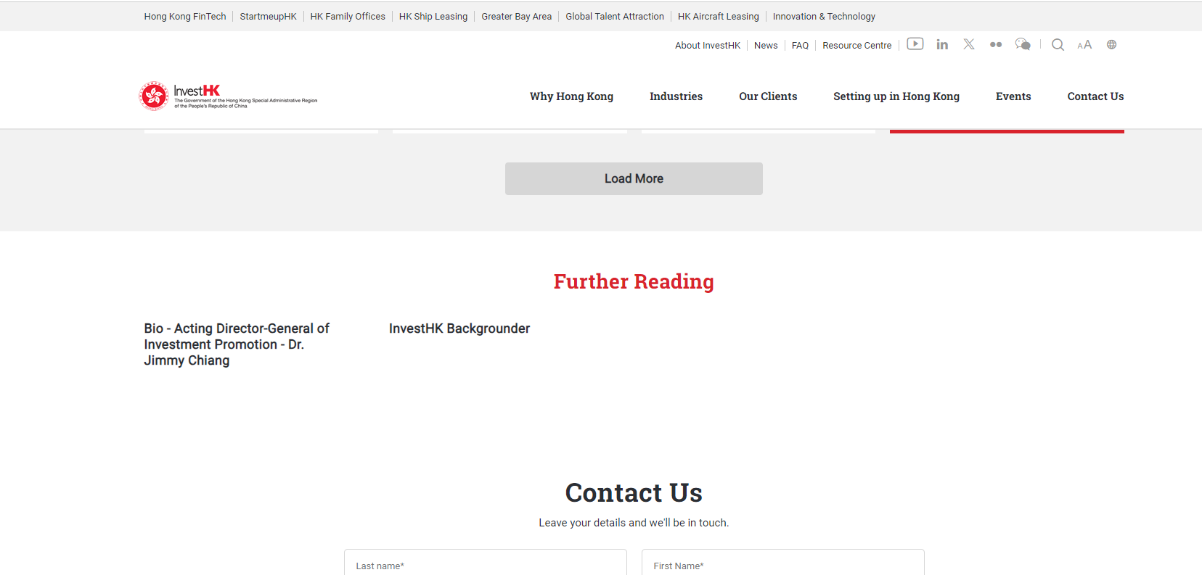
NEWS listing page further reading– CMS Control:
Field Name | Field Type | Remarks
Section Title | Text Field | If there are no item, this part will be hidden
Item Title | Text Field
Item Link URL | Content Picker | Content Picker allows user to select content from nodes in the same instance or to input external links.  User may define the display name in the content picker  It may be link or PDF

